International Journal of Advances and Applications in Convergent
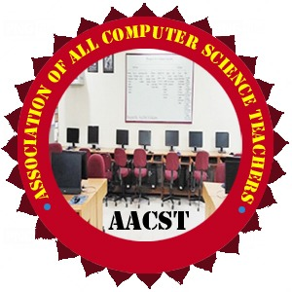
Studies & Transdisciplinary (IJ-AACST)
Bridging Discipline Bridging Knowledge
Published by: Association of All Computer Science Teachers (AACST)
Website: www.aacstij.org | Email: journaleditor@aacstij.org

Title of Paper
Author Name 1¹*, Dr. Author Name 2²
¹Department of Education, University of Pune, India
Affiliation of Author(s)
²School of Computer, Sharada University, India
*Corresponding Author Email: abc.xyz@gmail.com
ORCID (Corresponding Author): https://orcid.org/0000-0002-1234-5678 (It is optional)

ABSTRACT
This is a sample abstract. It should summarize the research objectives, methods, key findings, and conclusion in 150–250 words.
KEYWORDS: Provide 3–6 relevant keywords in alphabetical order for indexing and searchability.
1. INTRODUCTION (Font size 12, Left Alignment).
Describe the background and purpose of the study (Font size 11, Justified Alignment).

2. LITERATURE REVIEW / RELATED WORK
Discuss relevant previous work with proper citation.

3. RESEARCH METHODOLOGY
Explain the methods used.

4. RESULTS AND DISCUSSION
Present and interpret the findings.

5. CONCLUSION AND FUTURE SCOPE
Summarize results and propose future work.

6. CONFLIT OF INTEREST (CoI) (Optional, only for Funding)
Authors must declare any financial or personal relationships that could influence the work or its evaluation.

7. REFERENCES
Authors must follow a subject-appropriate referencing style consistently throughout the manuscript. The referencing format should align with the conventions of the author’s academic discipline or faculty. Commonly accepted styles include:
- APA (Social Sciences, Education),
- IEEE (Engineering, Computer Science),
- MLA (Languages like English, Hindi, Sanskrit, etc.),
- Chicago (History, Philosophy), etc.

8. ACKNOWLEDGMENT (Optional)

Mention any contributions or support received, especially financial or institutional assistance.

9. ABOUT THE AUTHOR(S) (Optional)
Brief bio and affiliation of each author in 50 words.

